| **Sr No.** | **Practical Name** |
| --- | --- |
| **1** | **Creating rasberrian and booting** |
| **2** | **Blinking of led (python)** |
| **3** | **Toggling of led (python)** |
| **4** | **Blinking of led (node js)** |
| **5** | **Toggling led (node js)** |
| **6** | **Blinking of led (node red)** |
| **7** | **Changing intensity of led (node red)** |
| **8** | **Camera (turn on the camera method) (python)**   * **Clicking 5 photos in a row in 5 nano sec** * **Capturing video** |
| **9** | **Display name 8*8 grid (python)** |
| **10** | **Stepper motor (rotate motor using python)** |
| **11** | **Web server (hosting web site using apache)** |

**Practical 1**

**Write the steps for preparing raspberry pi: hardware preparation and installation**

**Hardware Preparation:**

1. Gather all necessary components including a **Raspberry Pi board, a microSD card, a power supply, a keyboard, a mouse, and a monitor.**
2. Insert the microSD card into the microSD slot on the Raspberry Pi board.
3. Connect the power supply to the Raspberry Pi board.
4. Connect the keyboard, mouse, and monitor to the Raspberry Pi board.

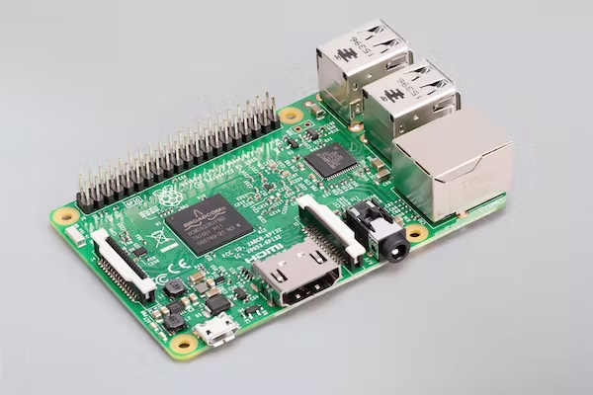



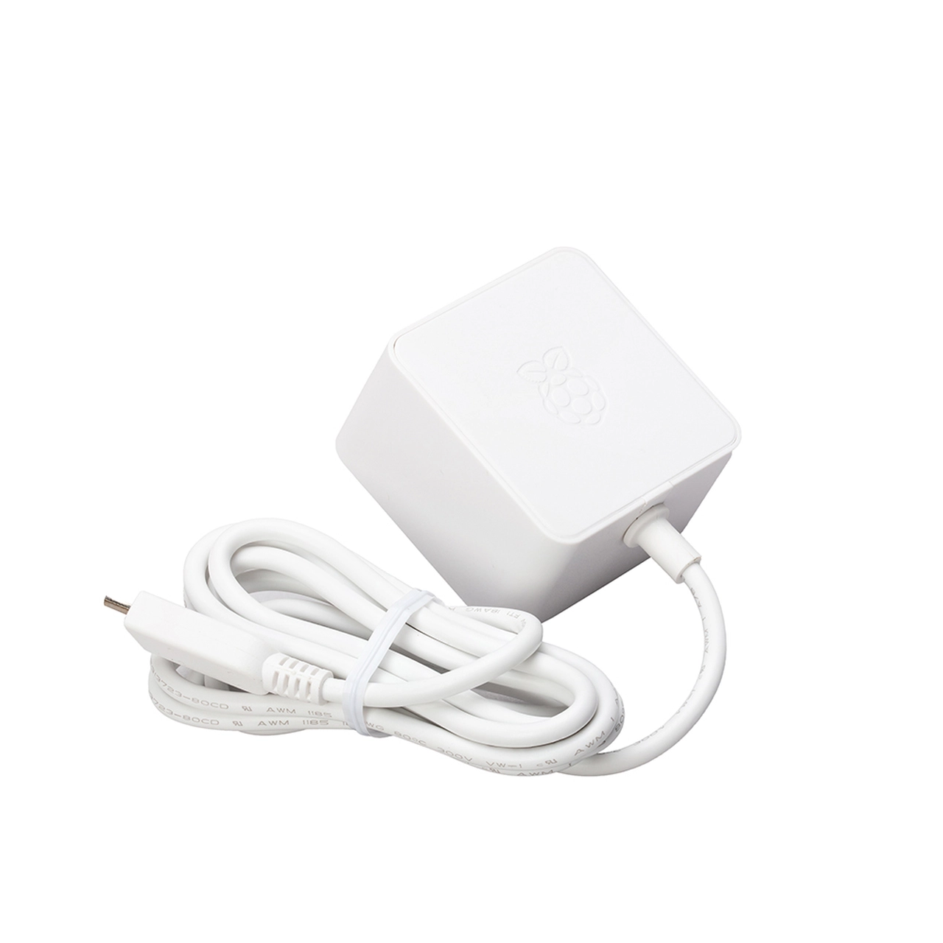

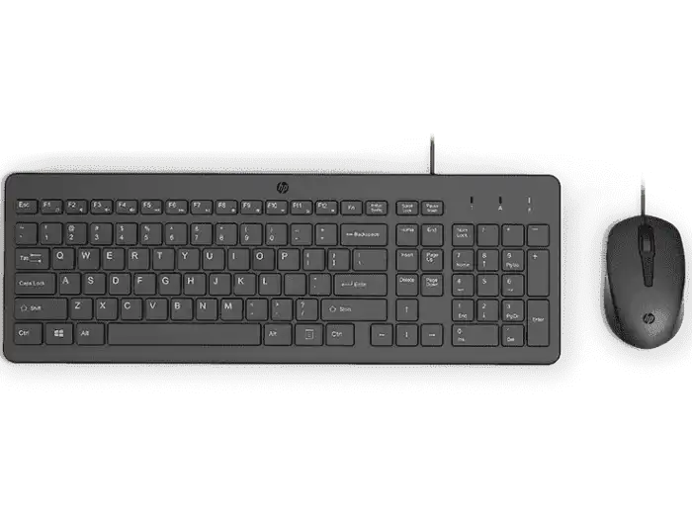



**Installation:**

1. Download the operating system image for Raspberry Pi from the official website.

<https://www.raspberrypi.com/software/operating-systems/>

1. Extract the downloaded image file using an extraction tool.
2. Write the extracted image file to the microSD card using a tool such as Raspberry Pi Imager.

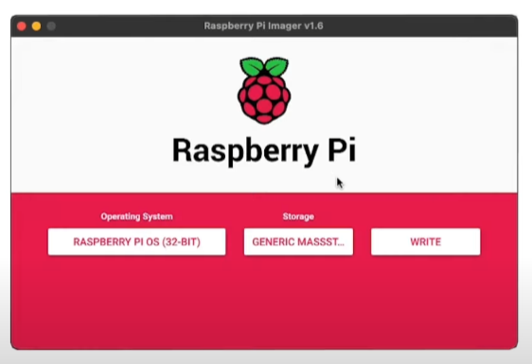

1. Insert the microSD card with the operating system into the Raspberry Pi board.

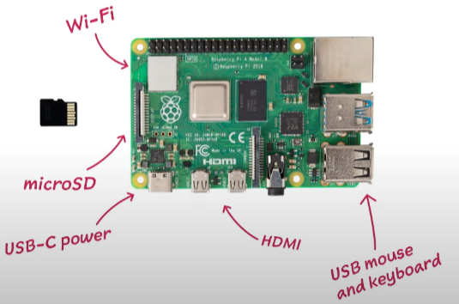

1. Connect the power supply to turn on the Raspberry Pi board.
2. Follow the on-screen instructions to complete the installation process.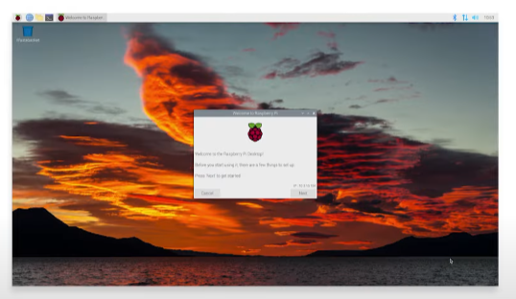

**Practical 2**

**GPIO: Light the LED with Python**

1. Connect the positive (longer) leg of an LED to GPIO pin 18 (BCM GPIO number) and the negative (shorter) leg to a ground pin on the Raspberry Pi.
2. Open the Python IDE by typing **python** or **python3** in the terminal.
3. Import the required libraries by typing the following commands:

| **import** RPi.GPIO **as** GPIO **import** time |
| --- |

1. Set the GPIO mode to BCM and define the output pin by typing the following commands:

| GPIO.setmode(GPIO.BCM) GPIO.setup(18, GPIO.OUT) |
| --- |

1. Use the **GPIO.output()** function to turn on the LED by setting the output to high. For example, type the following command to turn on the LED:

| GPIO.output(18, GPIO.HIGH) |
| --- |

1. Wait for a few seconds by using the **time.sleep()** function. For example, type the following command to wait for 2 seconds:

| time.sleep(2) |
| --- |

1. Turn off the LED by setting the output to low. For example, type the following command to turn off the LED:

| GPIO.output(18, GPIO.LOW) |
| --- |

1. Clean up the GPIO by using the **GPIO.cleanup()** function. For example, type the following command to clean up the GPIO:

| GPIO.cleanup() |
| --- |

1. Save the Python script with a filename of your choice and exit the Python IDE.
2. Run the Python script by typing the following command in the terminal:

| python filename.py |
| --- |

1. The LED should turn on for 2 seconds and then turn off.

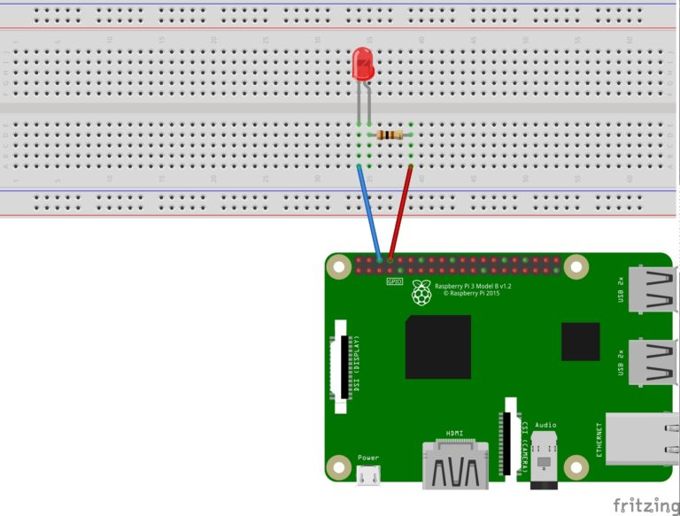

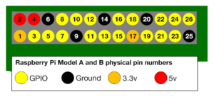

**Single Blinking of LED.py**

| **import** RPi.GPIO **as** GPIO # Import Raspberry Pi GPIO library **import** time GPIO.setmode(GPIO.BOARD) GPIO.setup(3,GPIO.OUT) GPIO.setwarnings(**False**) **while** **True**:  GPIO.output(3,**True**)  time.sleep(1)  print("blink")  GPIO.output(3,**False**)  time.sleep(1)  print("blink")  #one led |
| --- |

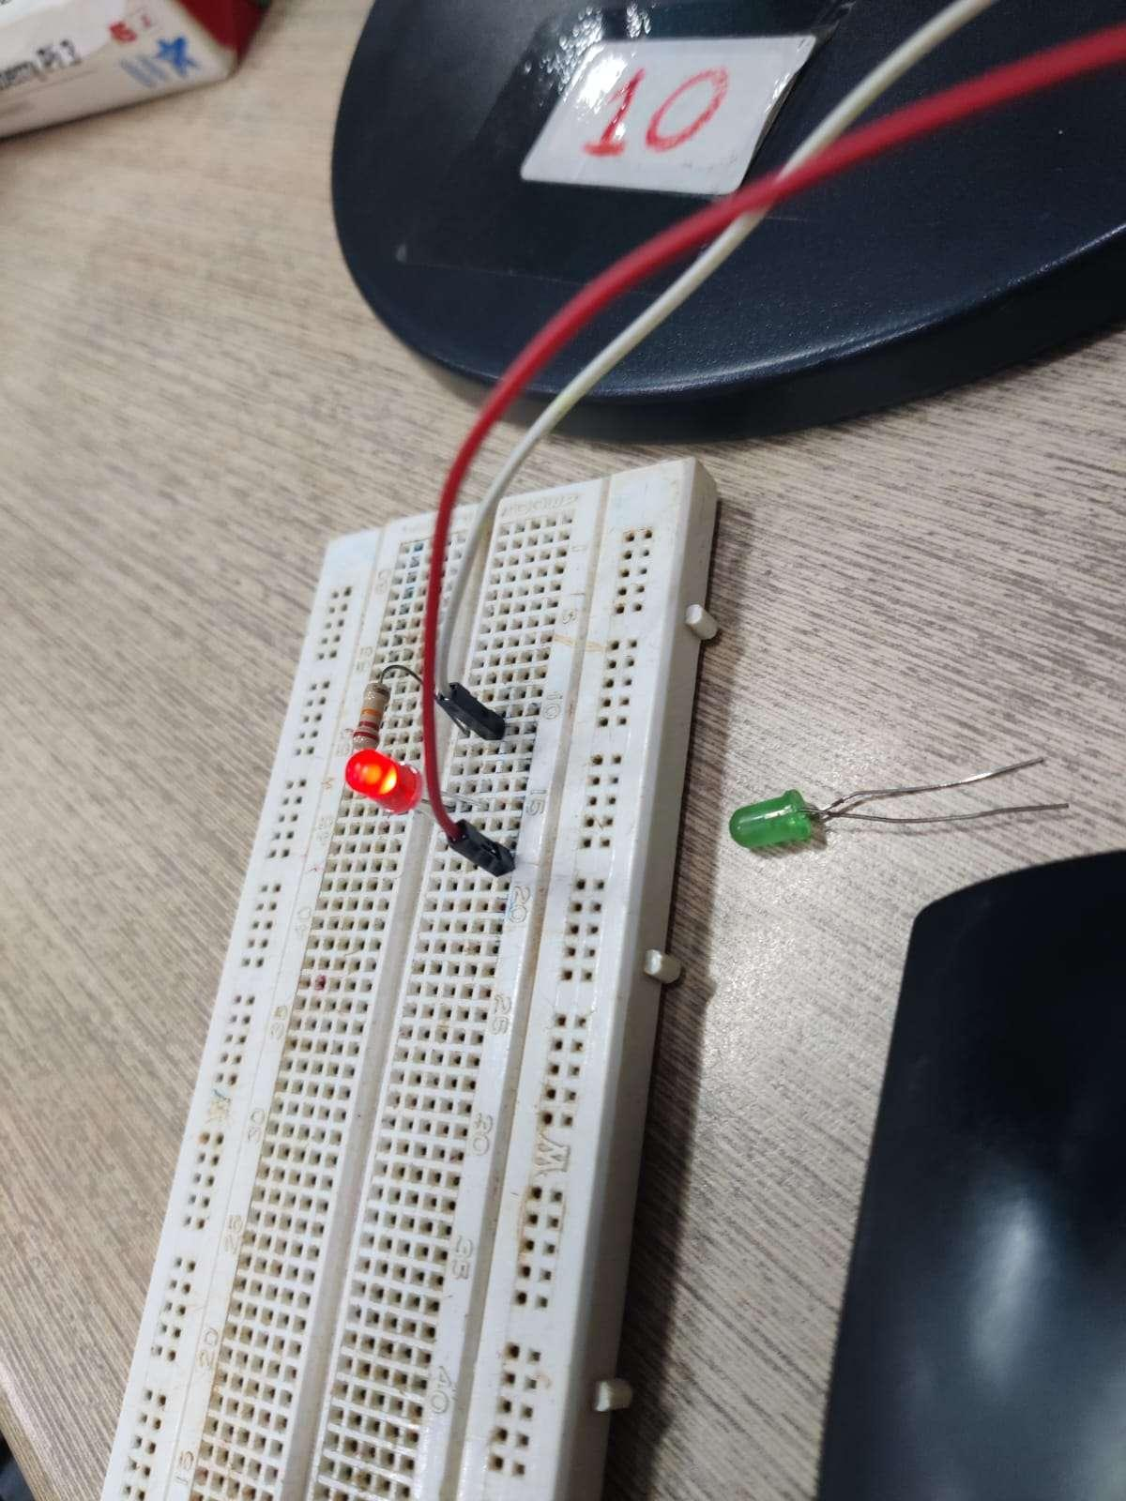

**Practical 3**

**GPIO: Toggle Light the LED with Python**

1. Connect the positive (longer) leg of an LED to GPIO pin 18 (BCM GPIO number) and the negative (shorter) leg to a ground pin on the Raspberry Pi.
2. Open the Python IDE by typing **python** or **python3** in the terminal.
3. Import the required libraries by typing the following commands:

| **import** RPi.GPIO **as** GPIO **import** time |
| --- |

1. Set the GPIO mode to BCM and define the output pin by typing the following commands:

| GPIO.setmode(GPIO.BCM) GPIO.setup(18, GPIO.OUT) |
| --- |

1. Use the **GPIO.output()** function to turn on the LED by setting the output to high. For example, type the following command to turn on the LED:

| GPIO.output(18, GPIO.HIGH) |
| --- |

1. Wait for a few seconds by using the **time.sleep()** function. For example, type the following command to wait for 2 seconds:

| time.sleep(2) |
| --- |

1. Turn off the LED by setting the output to low. For example, type the following command to turn off the LED:

| GPIO.output(18, GPIO.LOW) |
| --- |

1. Clean up the GPIO by using the **GPIO.cleanup()** function. For example, type the following command to clean up the GPIO:

| GPIO.cleanup() |
| --- |

1. Save the Python script with a filename of your choice and exit the Python IDE.
2. Run the Python script by typing the following command in the terminal:

| python filename.py |
| --- |

1. The LED should turn on for 2 seconds and then turn off.



**Two LED Toggle py**



| **import** RPi.GPIO **as** GPIO # Import Raspberry Pi GPIO library **from** time **import** sleep # Import the sleep function from the time module GPIO.setwarnings(**False**) # Ignore warning for now GPIO.setmode(GPIO.BCM) # Use physical pin numbering GPIO.setup(14, GPIO.OUT) # Set pin 8 to be an output pin and set initial value to low (off) #pov 8, neg 39 GPIO.setup(15,GPIO.OUT)#pov 10, neg 34 **while** **True**: # Run forever  GPIO.output(14, GPIO.HIGH) # Turn on  print("light on")  sleep(1) # Sleep for 1 second  GPIO.output(14, GPIO.LOW) # Turn off  print("light off")  GPIO.output(15, GPIO.HIGH) # Turn on  print("light on")  sleep(0.05) # Sleep for 1 second  GPIO.output(15, GPIO.LOW) # Turn off  print("light off")  #both negative on GND |
| --- |

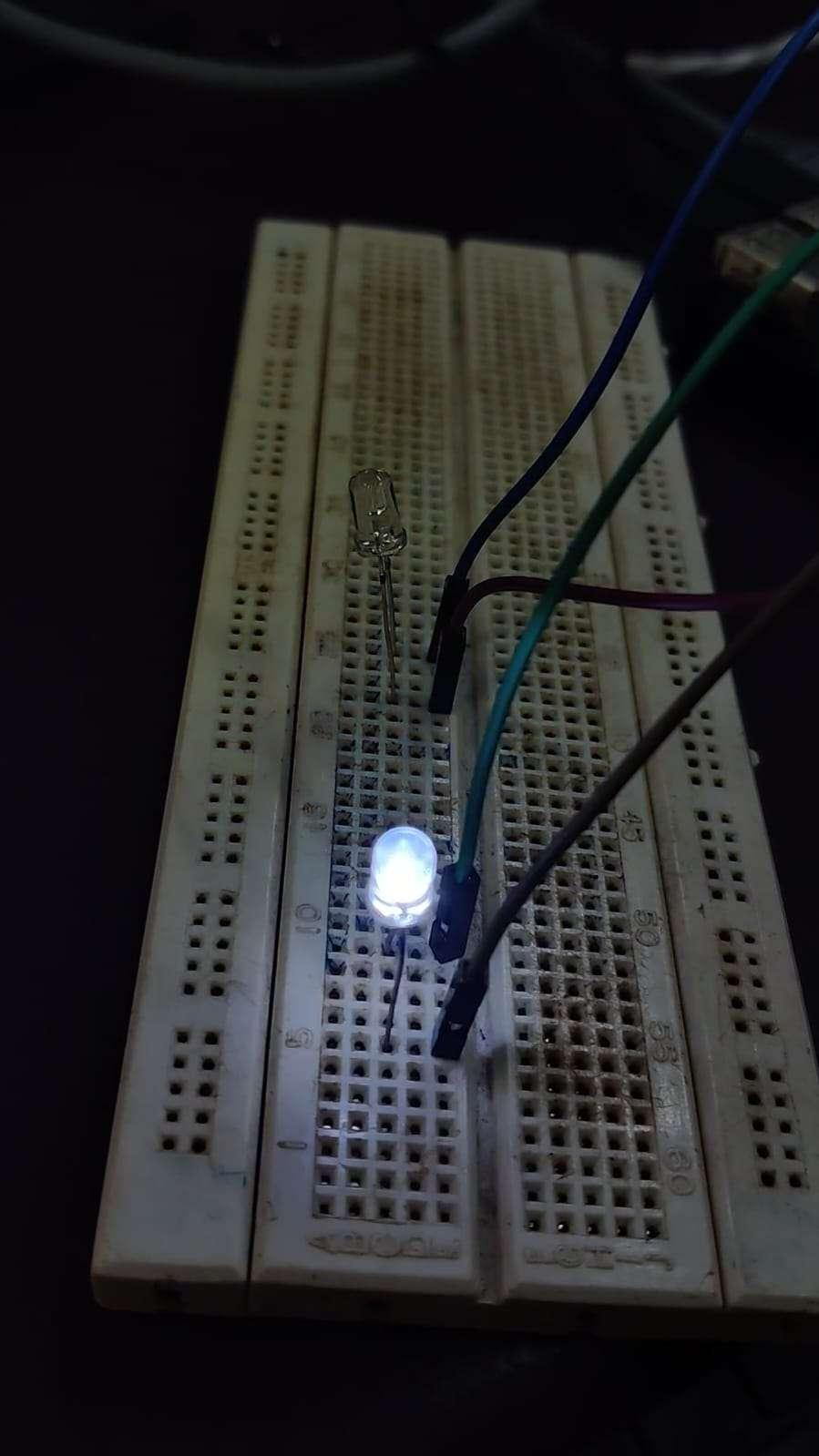

**Practical 4**

**Blinking of led in NODE.js**

1. Connect the LED to one of the GPIO pins on the Raspberry Pi. For example, you can connect the positive leg of the LED to GPIO 17 and the negative leg to a ground pin on the Pi.
2. Open a text editor and create a new JavaScript file, for example, led_blink.js.
3. Install the onoff module for Node.js by running the following command in a terminal:

| npm install onoff |
| --- |

This will install the onoff module, which provides a simple interface for controlling the GPIO pins on the Raspberry Pi.

1. Import the onoff module and create a Gpio instance for the LED pin:

| **const** Gpio = require('onoff').Gpio; **const** led = **new** Gpio(17, 'out'); |
| --- |

In this example, we are using GPIO 17 to control the LED. You can use a different GPIO pin by changing the pin number in the code to the desired pin number.

1. Use a loop to toggle the LED on and off:

| setInterval(() => {  led.writeSync(1);  setTimeout(() => {  led.writeSync(0);  }, 1000); }, 2000); |
| --- |

This code will turn the LED on for one second, then turn it off for one second, and then repeat indefinitely.

1. Save the script and exit the text editor.
2. Run the script using the following command:

| node led_blink.js |
| --- |

This will run the JavaScript file and blink the LED on and off.

Note that in this example, we are using GPIO 17 to control the LED. You can use a different GPIO pin by changing the pin number in the code to the desired pin number. Also note that the setInterval function is used to repeatedly execute the code that toggles the LED on and off. The setTimeout function is used to wait for one second before turning the LED off.

Create a .js file write this in terminal

| nano led_blink.js |
| --- |

After writing the code tap “ctrl+O” (you can again change the code also by tapping “tab” after this) to save and then tap “Esc” tap “ctrl+X” to go back to the terminal after saving

| node led_blink.js |
| --- |

**Code for 1 led blink in node.js:**

| **var** Gpio = require('onoff').Gpio;  **var** LED = **new** Gpio(2,'out');  **var** blinkInterval = setInterval(blinkLED, 250);  **function** **blinkLED**() {  **if** (LED.readSync() === 0) {  LED.writeSync(1);  } **else** { LED.writeSync(0);  } } **function** **endBlink**() {  clearInterval(blinkInterval);  LED.writeSync(0);  LED.unexport();  } setTimeout(endBlink, 5000);  console.log("hello"); |
| --- |



**Code for 2 led blink in node.js:**

| **const** Gpio = require('onoff').Gpio;  **const** led1 = **new** Gpio(14, 'out');  **const** led2 = **new** Gpio(15, 'out'); **while** (true) {   led1.writeSync(1);   console.log("light on");  sleep(1000);   led1.writeSync(0);   console.log("light off");  led2.writeSync(1);  console.log("light on");  sleep(50);   led2.writeSync(0);   console.log("light off"); } **function** **sleep**(ms) {  **return** **new** Promise(resolve => setTimeout(resolve, ms)); } |
| --- |

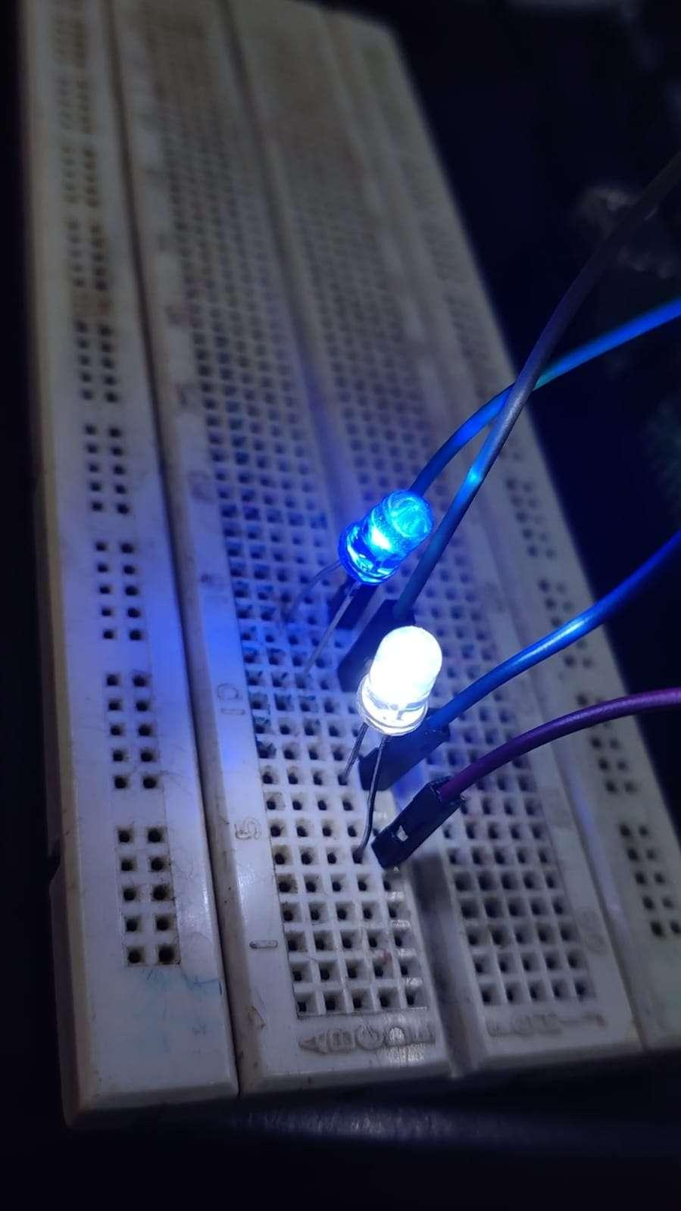

**Practical 5**

**Toggle of led in NODE.js**

1. Connect the LED to one of the GPIO pins on the Raspberry Pi. For example, you can connect the positive leg of the LED to GPIO 17 and the negative leg to a ground pin on the Pi.
2. Open a text editor and create a new JavaScript file, for example, led_blink.js.
3. Install the onoff module for Node.js by running the following command in a terminal:

| npm install onoff |
| --- |

This will install the onoff module, which provides a simple interface for controlling the GPIO pins on the Raspberry Pi.

1. Import the onoff module and create a Gpio instance for the LED pin:

| **const** Gpio = require('onoff').Gpio; **const** led = **new** Gpio(17, 'out'); |
| --- |

In this example, we are using GPIO 17 to control the LED. You can use a different GPIO pin by changing the pin number in the code to the desired pin number.

1. Use a loop to toggle the LED on and off:

| setInterval(() => {  led.writeSync(1);  setTimeout(() => {  led.writeSync(0);  }, 1000); }, 2000); |
| --- |

This code will turn the LED on for one second, then turn it off for one second, and then repeat indefinitely.

1. Save the script and exit the text editor.
2. Run the script using the following command:

| node led_blink.js |
| --- |

This will run the JavaScript file and blink the LED on and off.

Note that in this example, we are using GPIO 17 to control the LED. You can use a different GPIO pin by changing the pin number in the code to the desired pin number. Also note that the setInterval function is used to repeatedly execute the code that toggles the LED on and off. The setTimeout function is used to wait for one second before turning the LED off.

Create a .js file write this in terminal

| nano led_blink.js |
| --- |

After writing the code tap “ctrl+O” (you can again change the code also by tapping “tab” after this) to save and then tap “Esc” tap “ctrl+X” to go back to the terminal after saving

| node led_blink.js |
| --- |

**LED Toggle nodejs**

| const Gpio = require('onoff').Gpio;  const led1 = new Gpio(14, 'out');  const led2 = new Gpio(15, 'out');  **while** (true) {   led1.writeSync(1);   console.log("light on");  sleep(1000);   led1.writeSync(0);   console.log("light off");  led2.writeSync(1);   console.log("light on");  sleep(50);   led2.writeSync(0);   console.log("light off"); } function sleep(ms) {  **return** new Promise(resolve => setTimeout(resolve, ms)); } |
| --- |



Practical 06

**Aim: To blink an LED using Node Red**

Installing and Upgrading Node-RED

We provide a script to install Node.js, npm and Node-RED onto a Raspberry Pi. The script can also be used to upgrade an existing install when a new release is available.

Running the following command will download and run the script. If you want to review the contents of the script first, you can view it on Github.

| bash <(curl -sL https://raw.githubusercontent.com/node-red/linux-installers/master/deb/update-nodejs-**and**-nodered) |
| --- |

This script will:

● remove the existing version of Node-RED if present.

● if it detects Node.js is already installed, it will ensure it is at least v14. If less than v14 it will stop and let the user decide whether to stay with Node-RED version 1 - or upgrade Nodejs to a more recent LTS version. If nothing is found it will install the Node.js 16 LTS release using the NodeSource package.

● install the latest version of Node-RED using npm.

● optionally install a collection of useful Pi-specific nodes.

● setup Node-RED to run as a service and provide a set of commands to work with the service.

**Launch Node-RED App in Raspberry Pi**

There are two ways we can start Node-red:

By using Raspberry menu taskbar: go to right raspberry taskbar>> go to Programming >> click Node-Red.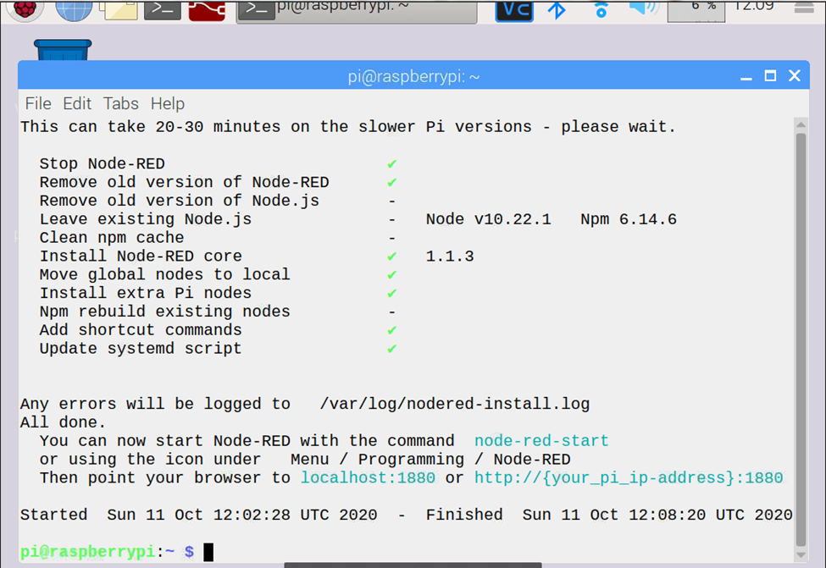

By using SSH Command:

node-red-start

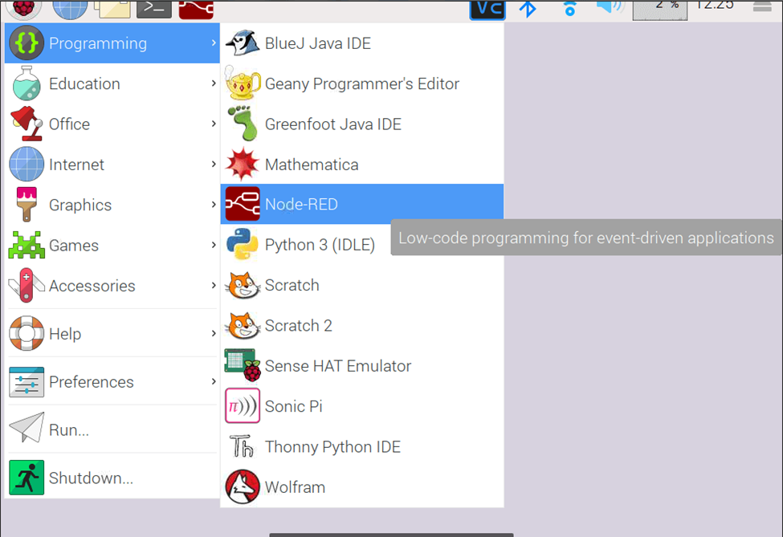

after command you will get window and you can find Server now running at http://127.0.0.1:1880/



Once you see this, go to menu->internet and launch the chromium web browser. While your Raspberry pi does not need the internet to run Node-Red, it uses a browser as its interface.

Enter http://127.0.0.1:1880/ in chromium browser, you will get Node-Red interface window running with pre-installed nodes from node.js.

The Node-Red interface having flow panel, the nodes palette, the debug console and the info console as highlighted in the image above

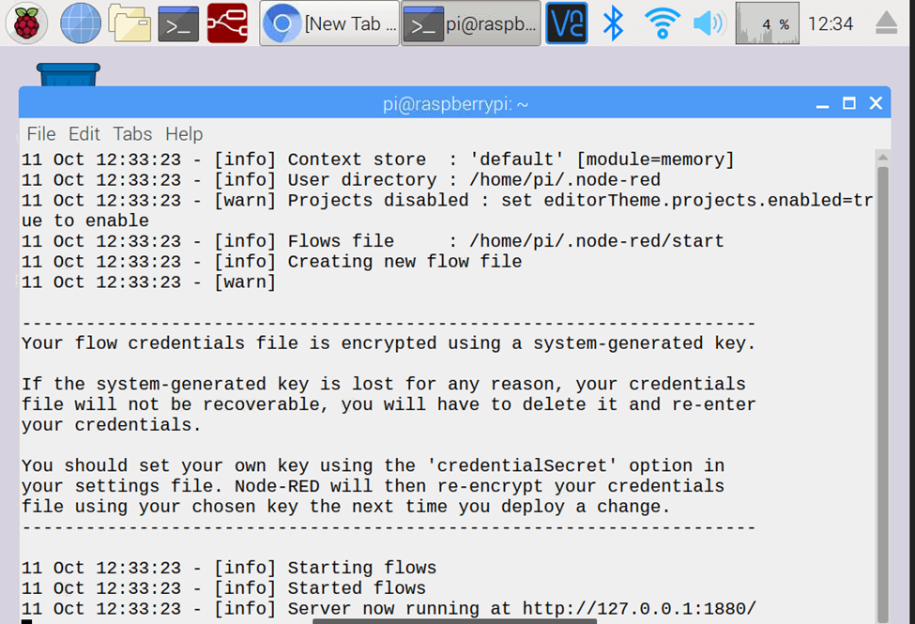

Now our Node-Red is ready to draw flow with preinstalled node as per requirement.

On Launching Node-Red you will get below terminal window which will shows some basic command information about Node-Red and will also give you the Browser IP address with port number (http://127.0.0.1:1880) to access node-red application or Node-Red interface and flows on chromium browser.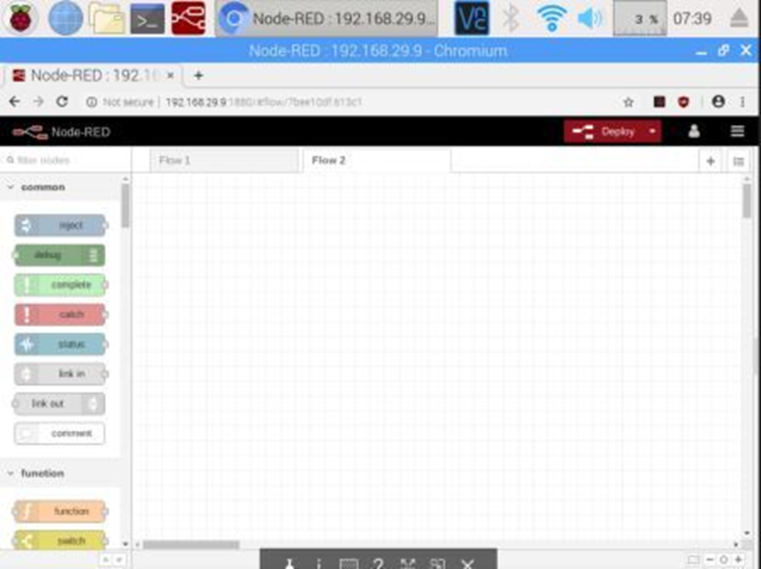

The Node-Red interface comprises of the flow panel, the nodes palette, the debug console and the info console as highlighted in the image above.

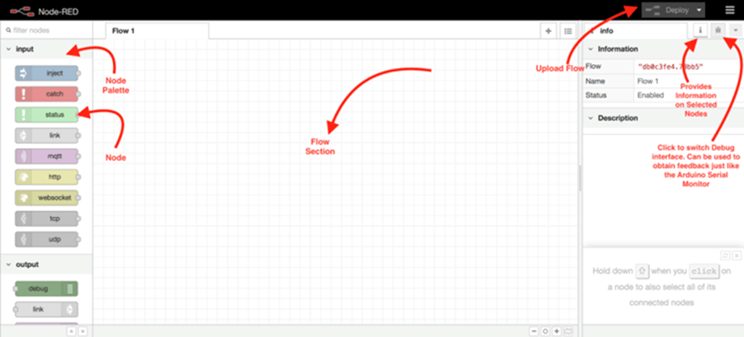

**Preparing Circuit Diagram**

Connect an LED between PIN40 (GPIO21) and PIN39 (GROUND). As said earlier, we cannot draw more than 15mA from any one of these pins, so to limit the current we are connecting a 220Ω or 1KΩ resistor in series with the LED.

**Creating a Flow in Node-RED for Blinking LED**

After completing circuit arrangement by connecting LED as per circuit diagram we need start creating Flow in Node-red Interface.

Flows in Node-Red is nothing But program like other IDE like Arduino Sketch. So let build the Flow for blinking LED.

To Create Flow for blinking LED we need enable or control Raspberry PI GPIO though Nodes . Node-Red having preinstalled node for supporting GPIO at left nodes area. Just scroll down to find required rpigpio nodes

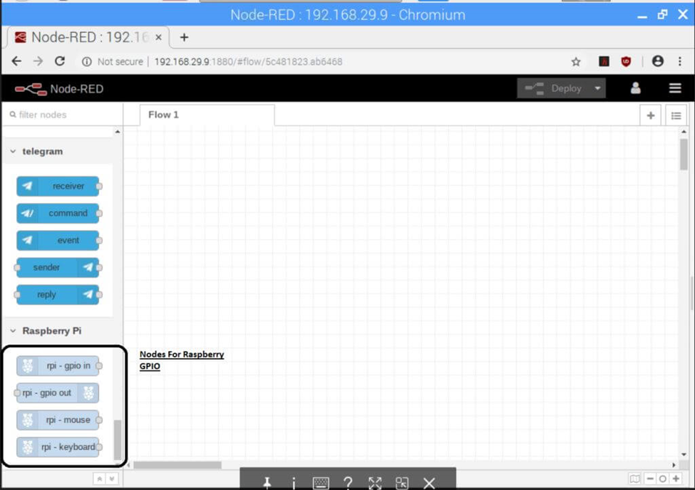

Here we will find rpi-gpip in to configure particular gpio as input and rpi-gpip out to configure particular gpio as output.

For our project we need only rpi-gpip out node to blink LED. To Create a flow just drag this node in flow as like below.

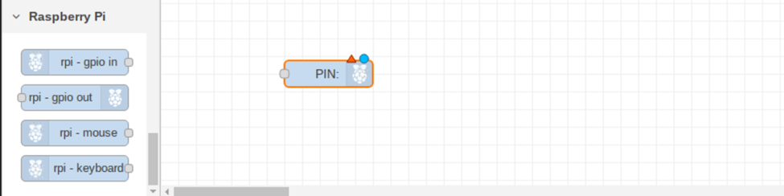

Now Edit this node by double click on it to configure which PIN you need to assign as output to Blink LED. As we are going connect LED on 40th GPIO pin we will select 40 number.



After Editing the GPIO node we need to pass 0 & 1 to make LED on/off using Inject nodes. Let us configure Inject node as per our requirement.

**ON LED**

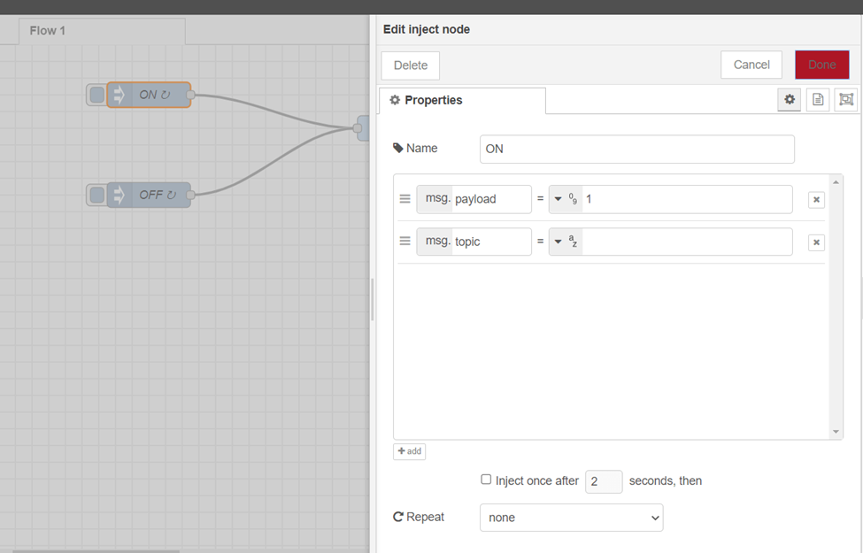

**OFF LED**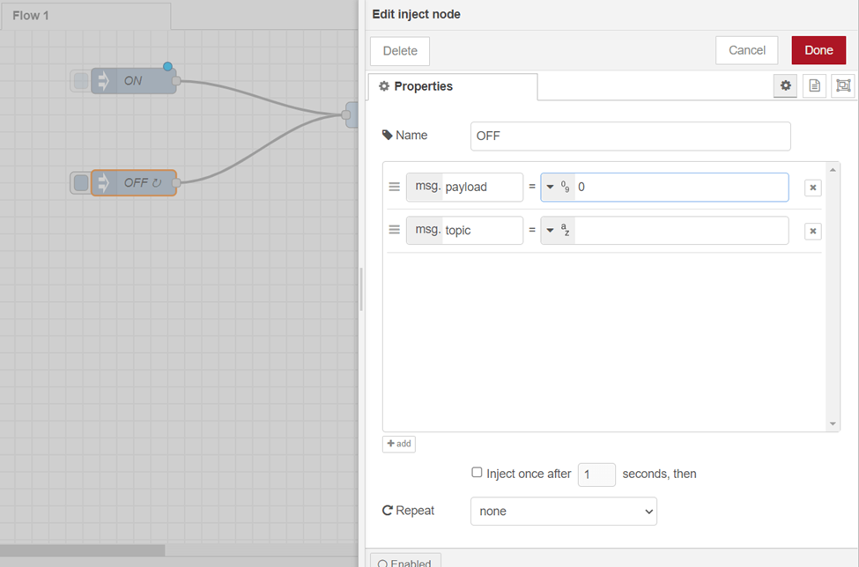

**Deploy the Flow**

Next step is for us to deploy the flow on the raspberry pi. Click the red deploy button. You should see “successfully deployed” flash at the top of the screen as shown below.

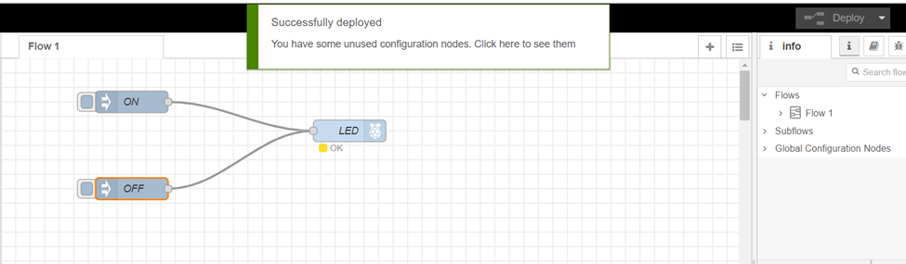

**Injecting value to make LED ON /OFF**

Click the grey button behind the inject nodes to activate each of the nodes.

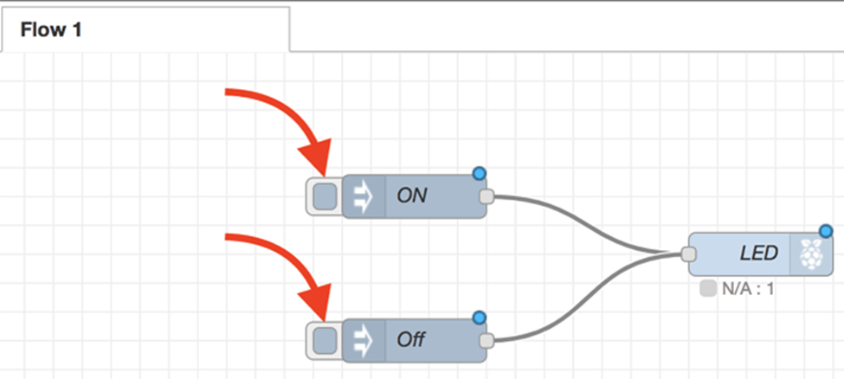

Practical 07

**Aim: Changing intensity of LED**

Here are the steps to create this flow:

1. Open Node-RED in your web browser and create a new flow.

2. Add an "inject" node from the "input" category to the flow.

3. Double-click the inject node to open its configuration panel. Change the "Payload type" to "number" and set the "Payload" to the initial duty cycle percentage (e.g., 50).

4. Add a "PWM" node from the "pi-gpio" category to the flow.

5. Double-click the PWM node to open its configuration panel. Set the "Pin" to the GPIO pin number (e.g., 18), and set the "Frequency" to the desired PWM frequency (e.g., 100).

6. Add a "slider" node from the "dashboard" category to the flow.

7. Double-click the slider node to open its configuration panel. Set the "Label" to "LED Intensity", set the "Range" to "0-100", and set the "Initial value" to the initial duty cycle percentage (e.g., 50).

8. Connect the "slider" node to the "PWM" node.

9. Add a "chart" node from the "dashboard" category to the flow.

10. Double-click the chart node to open its configuration panel. Set the "Group" to "LED Intensity", set the "Label" to "Duty Cycle Percentage", and set the "X-axis format" to "HH:mm:ss".

11. Connect the "inject" node to the "chart" node.

12. Deploy the flow and access the Node-RED dashboard by opening a web browser and entering the IP address of your Raspberry Pi followed by :1880/ui (e.g., http://192.168.1.100:1880/ui).

13. Use the slider to adjust the duty cycle percentage, and observe the LED intensity changing accordingly. The chart should also display the duty cycle percentage over time.

14. You can customize this flow by changing the GPIO pin number, PWM frequency, and other settings to match your specific hardware setup.

**Practical 8**

**SPI: Camera Connection and capturing Images using SPI**

The Raspberry Pi 3 does not support SPI for camera connections, but it does support the Raspberry Pi Camera Module which connects to the CSI (Camera Serial Interface) port. Here are the steps to connect and capture images using the Raspberry Pi Camera Module:

1. Connect the Raspberry Pi Camera Module to the Raspberry Pi 3 using the CSI port. The port is located between the HDMI and audio jack ports.



1. Start up your Raspberry Pi.
2. Go to the main menu and open the Raspberry Pi Configuration tool.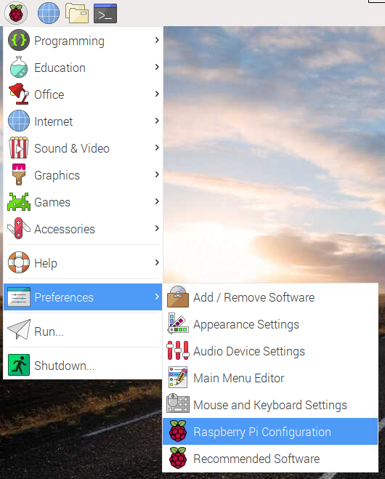
3. Select the Interfaces tab and ensure that the camera is enabled:

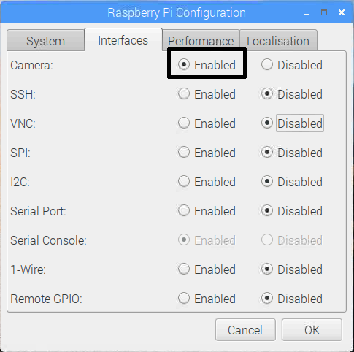

1. Reboot your Raspberry Pi.
2. Now your Camera Module is connected and the software is enabled, try out the command line tools **raspistill** and **raspivid**.
3. Open a terminal window by clicking the black monitor icon in the taskbar:

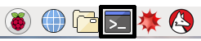

1. Type in the following command to take a still picture and save it to the Desktop:

| raspistill -o Desktop/image.jpg |
| --- |

1. Press Enter to run the command.
2. When the command runs, you can see the camera preview open for five seconds before a still picture is taken.
3. Now record a video with the Camera Module by using the following **raspivid** command:

| raspivid -o Desktop/video.h264 |
| --- |

1. In order to play the video file, double-click the **video.h264** file icon on the Desktop to open it in VLC Media Player.

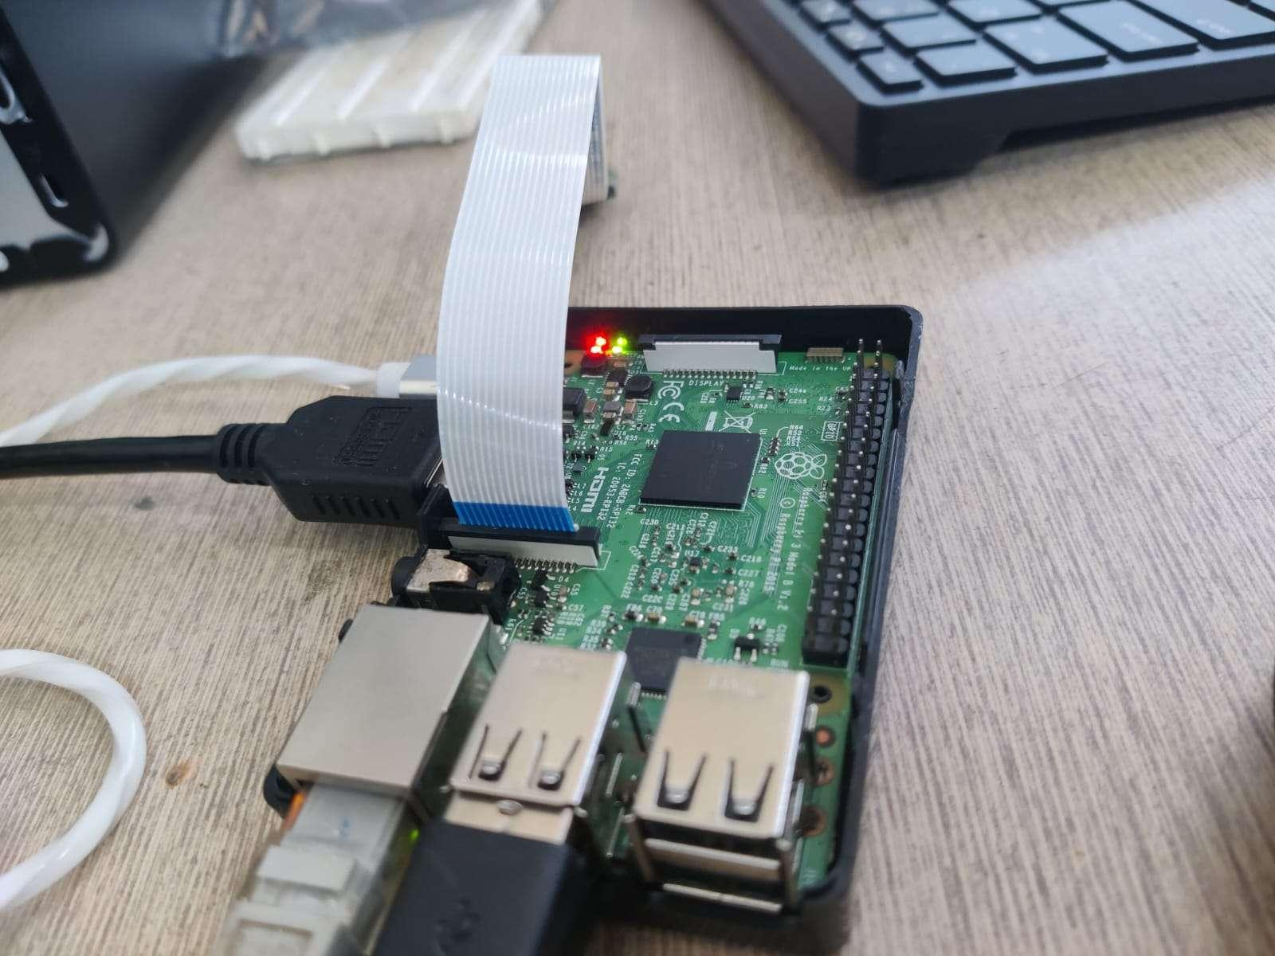

**Practical 9**

**GPIO: LED Grid Module: Program the 8X8 Grid with Different Formulas**

1. Connect the 8x8 LED grid module to the Raspberry Pi 3 using the GPIO pins. Follow the wiring diagram of the module to connect the pins correctly.
2. Open the Python IDE by typing **python** or **python3** in the terminal.
3. Import the required libraries by typing the following commands:

| **import** RPi.GPIO **as** GPIO **import** time |
| --- |

1. Set the GPIO mode to BCM and define the output pins by typing the following commands:

| GPIO.setmode(GPIO.BCM) GPIO.setup(17, GPIO.OUT)  GPIO.setup(18, GPIO.OUT)  GPIO.setup(27, GPIO.OUT)  GPIO.setup(22, GPIO.OUT)  GPIO.setup(23, GPIO.OUT)  GPIO.setup(24, GPIO.OUT)  GPIO.setup(25, GPIO.OUT)  GPIO.setup(4, GPIO.OUT)  GPIO.setup(5, GPIO.OUT)  GPIO.setup(6, GPIO.OUT)  GPIO.setup(12, GPIO.OUT)  GPIO.setup(13, GPIO.OUT)  GPIO.setup(16, GPIO.OUT)  GPIO.setup(19, GPIO.OUT)  GPIO.setup(20, GPIO.OUT)  GPIO.setup(21, GPIO.OUT) |
| --- |

1. Define a list of lists to represent the LED grid matrix. For example, type the following command to define an 8x8 matrix:

| matrix = [[0]*8 **for** i **in** range(8)] |
| --- |

1. Define a function to display the LED grid based on the matrix. For example, the following function displays the grid for

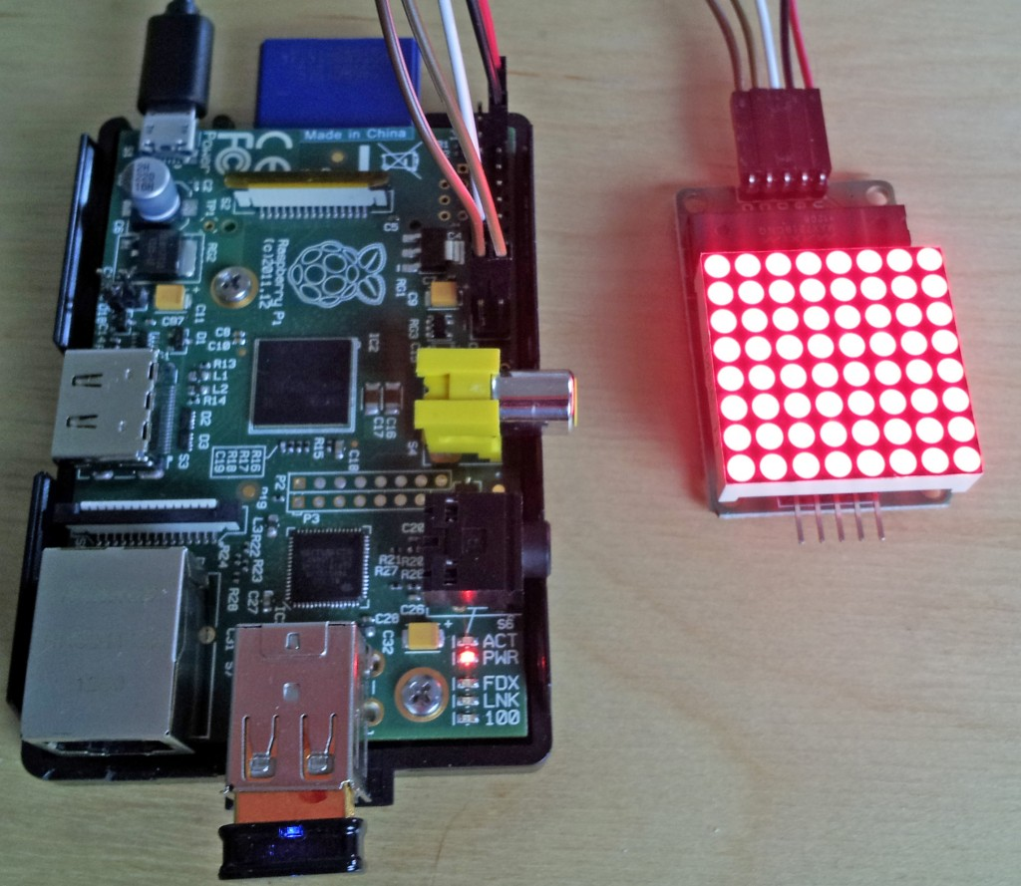

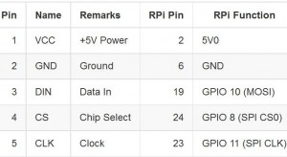

**Code Matrix 8x8:**

| **import** re **import** time **import** argparse **from** luma.led_matrix.device **import** max7219 **from** luma.core.interface.serial **import** spi,noop **from** luma.core.render **import** canvas **from** luma.core.virtual **import** viewport **from** luma.core.legacy **import** text,show_message **from** luma.core.legacy.font **import** proportional,CP437_FONT,TINY_FONT,SINCLAIR_FONT,LCD_FONT **def** **demo**():  serial =spi(port =0,device=0,gpio=noop())  device=max7219(serial)  print("created device")  msg="Led GRID MODULE DEMO"  print(msg) show_message(device,msg,fill="white",font=proportional(CP437_FONT),scroll_delay=0.05)  time.sleep(0.5)   msg=input("enter your text: ")  sd=float(input("enter scroll delay amount"))  print(msg) show_message(device,msg,fill="white",font=proportional(LCD_FONT),scroll_delay=sd)   print("brightness")  show_message(device,msg,fill="white",scroll_delay=0.1)  time.sleep(0.5)  print("alternative font!") show_message(device,msg,fill="white",font=SINCLAIR_FONT,scroll_delay=0.1) **if** __name__=="__main__":  **try**:  demo()  **except** KeyboardInterrupt:  **pass** |
| --- |

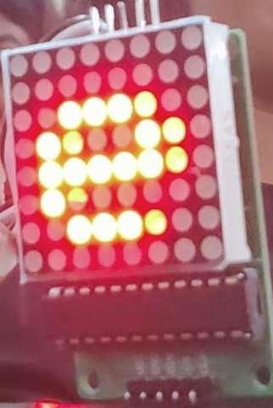

**Practical 10**

**Stepper Motor Control: PWM to manage stepper motor speed.**

**Code for stepper motor**

1. Stepper motor is a brushless DC motor that divides the full rotation angle of 360° into number of equal steps.
2. The motor is rotated by applying certain sequence of control signals. The speed of rotation can be changed by changing the rate at which the control signals are applied.
3. For more information about Stepper Motor, its control sequence and how to use it, refer the topic Stepper Motor in the sensors and modules section.
4. Raspberry Pi’s GPIOs can be used to control stepper motor rotation. We can generate sequence of control signals on the GPIO pins of Raspberry Pi. To know more about Raspberry Pi GPIO refer Raspberry Pi GPIO Access.

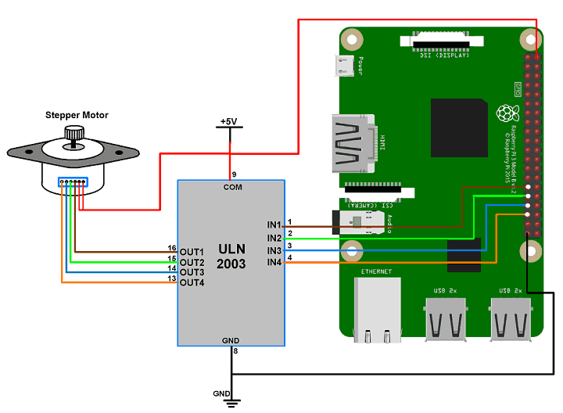

Rotate Stepper Motor using Raspberry Pi

Let’s rotate a Stepper Motor in clockwise and counter-clockwise directions alternately.

1. Here, we are using six wire unipolar stepper motor. Only four wires are required to control this stepper motor. The two center tap wires of the stepper motor are connected to the 5V supply.
2. ULN2003 driver is used to drive unipolar stepper motor.
3. We will interface Stepper Motor with Raspberry Pi using Python language. In this program, we have used the keyboard key as input for selecting motor rotation direction (i.e. clockwise or anti-clockwise).

**Code:**

| **import** RPi.GPIO **as** GPIO **from** time **import** sleep **import** sys motor_channel = (29,31,33,35)  GPIO.setwarnings(**False**) GPIO.setmode(GPIO.BOARD) #for defining more than 1 GPIO channel as input/output use GPIO.setup(motor_channel, GPIO.OUT) motor_direction = input('select motor direction a=anticlockwise, c=clockwise: ') **while** **True**:  **try**:  **if**(motor_direction == 'c'):  print('motor running clockwise\n')  GPIO.output(motor_channel, (GPIO.HIGH,GPIO.LOW,GPIO.LOW,GPIO.HIGH))  sleep(0.05)  GPIO.output(motor_channel, (GPIO.HIGH,GPIO.HIGH,GPIO.LOW,GPIO.LOW))  sleep(0.05)  GPIO.output(motor_channel, (GPIO.LOW,GPIO.HIGH,GPIO.HIGH,GPIO.LOW))  sleep(0.05)  GPIO.output(motor_channel, (GPIO.LOW,GPIO.LOW,GPIO.HIGH,GPIO.HIGH))  sleep(0.05)  **elif**(motor_direction == 'a'):  print('motor running anti-clockwise\n')  GPIO.output(motor_channel, (GPIO.HIGH,GPIO.LOW,GPIO.LOW,GPIO.HIGH))  sleep(0.005)  GPIO.output(motor_channel, (GPIO.LOW,GPIO.LOW,GPIO.HIGH,GPIO.HIGH))  sleep(0.005)  GPIO.output(motor_channel, (GPIO.LOW,GPIO.HIGH,GPIO.HIGH,GPIO.LOW))  sleep(0.005)  GPIO.output(motor_channel, (GPIO.HIGH,GPIO.HIGH,GPIO.LOW,GPIO.LOW))  sleep(0.005)   **except** KeyboardInterrupt:  motor_direction = input('select motor direction a=anticlockwise, c=clockwise or q=exit: ')  **if**(motor_direction == 'q'):  print('motor stopped')  sys.exit(0) |
| --- |

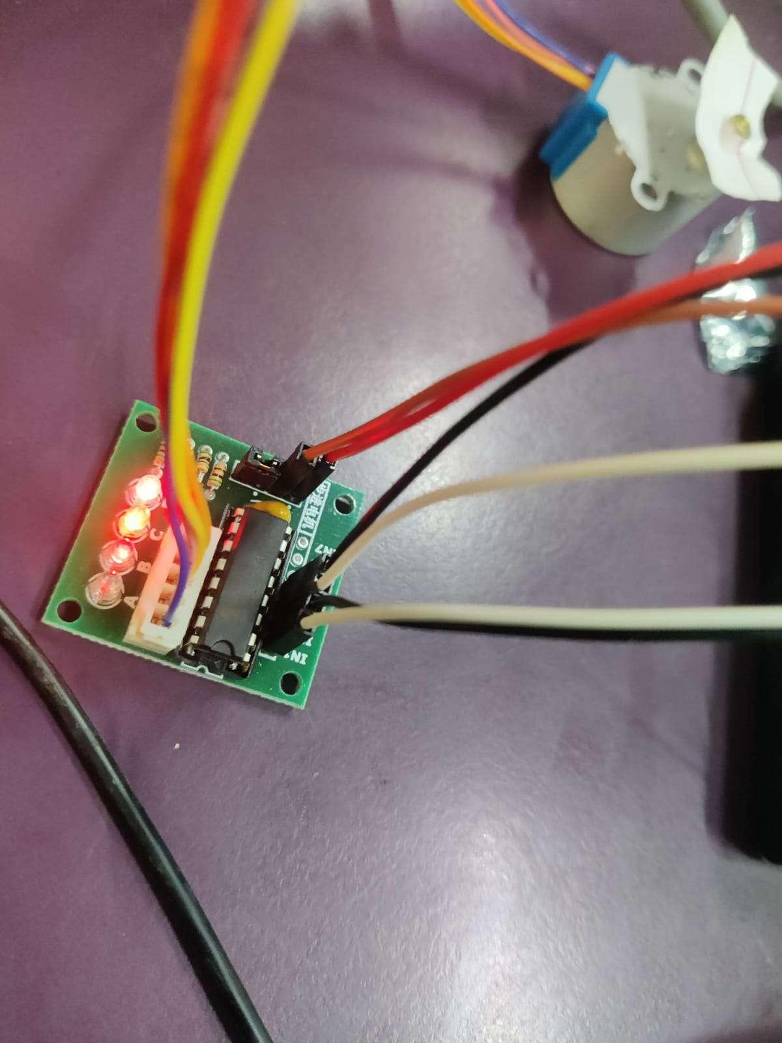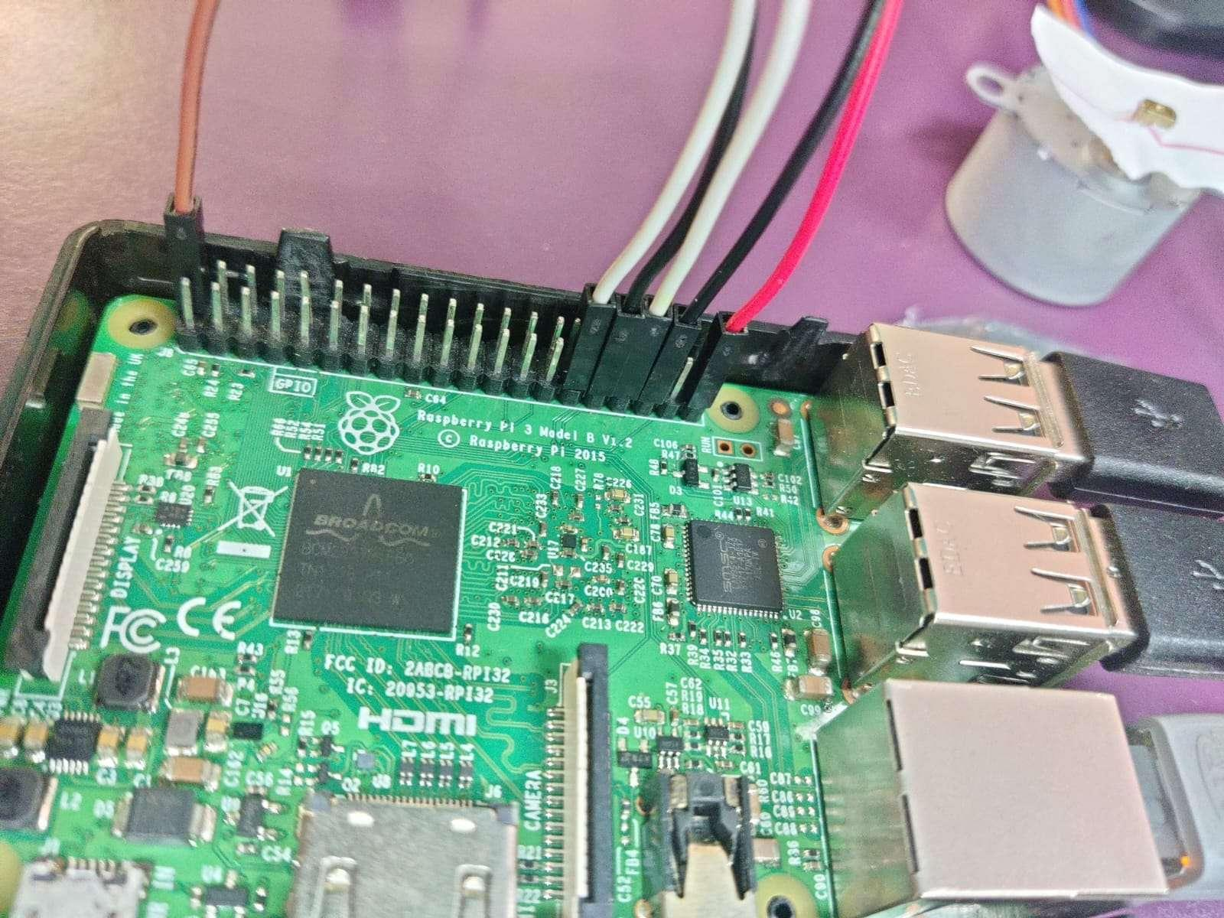

**Practical 11**

**Web Server(Hosting website using apache)**

To host a website on an RPi3 using Apache, you can follow these steps:

1. Install Apache web server by running the following command in the terminal:

| sudo apt-get update sudo apt-get install apache2 -y |
| --- |

1. you can enter the hostname command into the terminal to retrieve it.

| hostname -I |
| --- |

1. Verify that Apache is running by opening a web browser on another computer and entering the IP address of your Raspberry Pi followed by a forward slash, for example:

| http://192.168.1.100/ |
| --- |

If Apache is running, you should see the default Apache web page.

1. Create a directory in the default Apache document root directory (/var/www/html/) to hold your website files. For example, you can create a directory called example.php:

| sudo mkdir /var/www/html/example.php |
| --- |

1. Create a simple HTML file in your new directory to test the web server. For example, create a file called index.html with the following content:

| sudo nano /var/www/html/example.php |
| --- |

**Code:**

| <!DOCTYPE html> <html> <body> <?php echo "Today is " . date('Y-m-d H:i:s'); ?> </body> </html> |
| --- |

1. Test your website by navigating to http://<your-rpi-ip-address>/example.php in a web browser on another computer. You should see the "Hello World!" message from your index.html file.

